**CSA1518-CLOUD COMPUTING**

V.Mrudula

192011395

**EXPT 12**: Demonstrate Infrastructure as a Service (IaaS) by creating a resources group using a Public Cloud Service Provider (Azure), configure with minimum CPU, RAM, and Storage.

IMPLEMENTATION:

STEP 1:SELECT RESOURCE GROUP

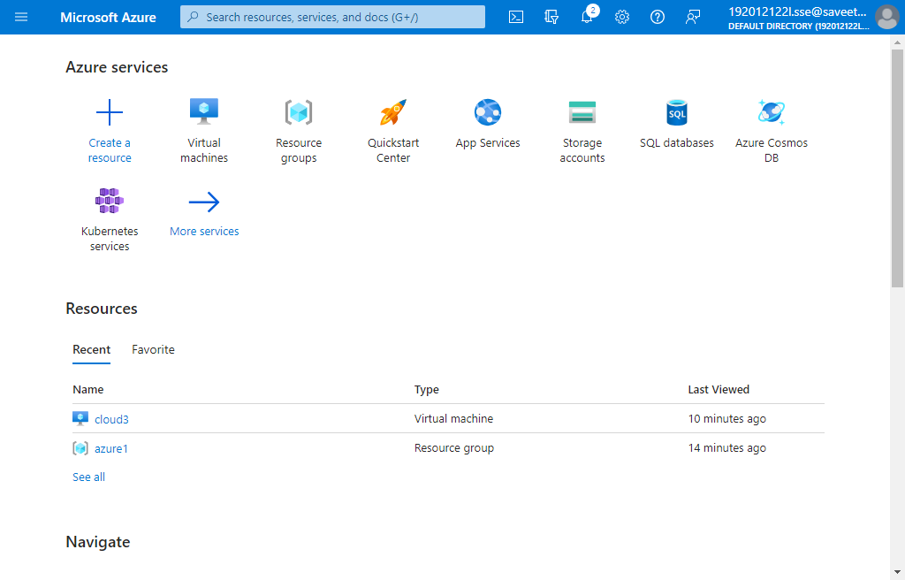

STEP 2: GIVE DETAILS FOR RESOURCE GROUP

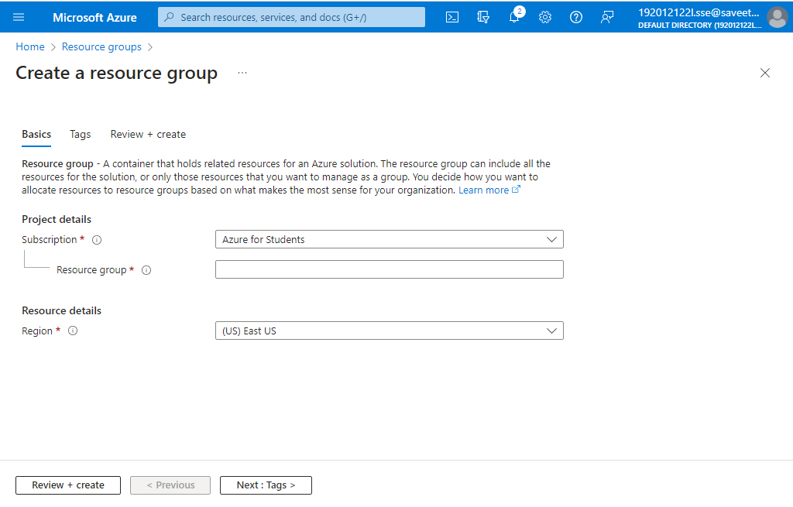

STEP 3:ENTER NAME AND VALUE FOR RESOURCE GROUP

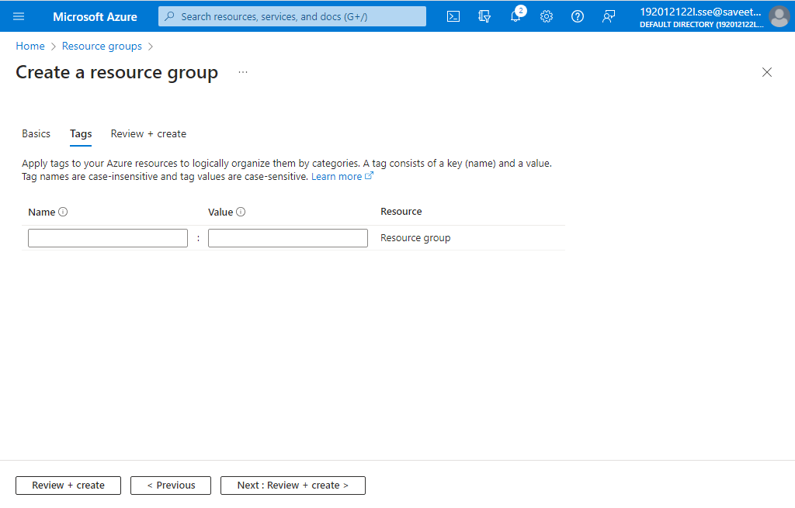

STEP 4:CLICK ON REVIEW+CREATE AND ALL THE DATA IS DISPLAYED

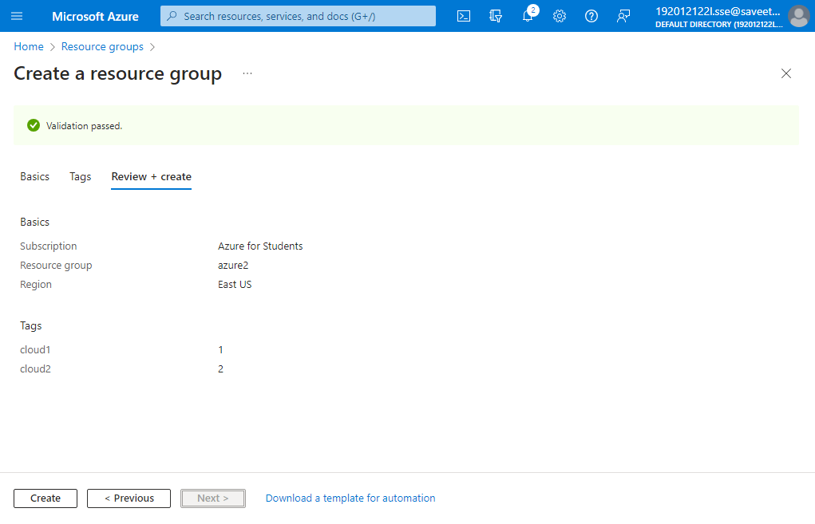

STEP 5:CLICK ON CREATE AND RESOURCE GROUP IS CREATED

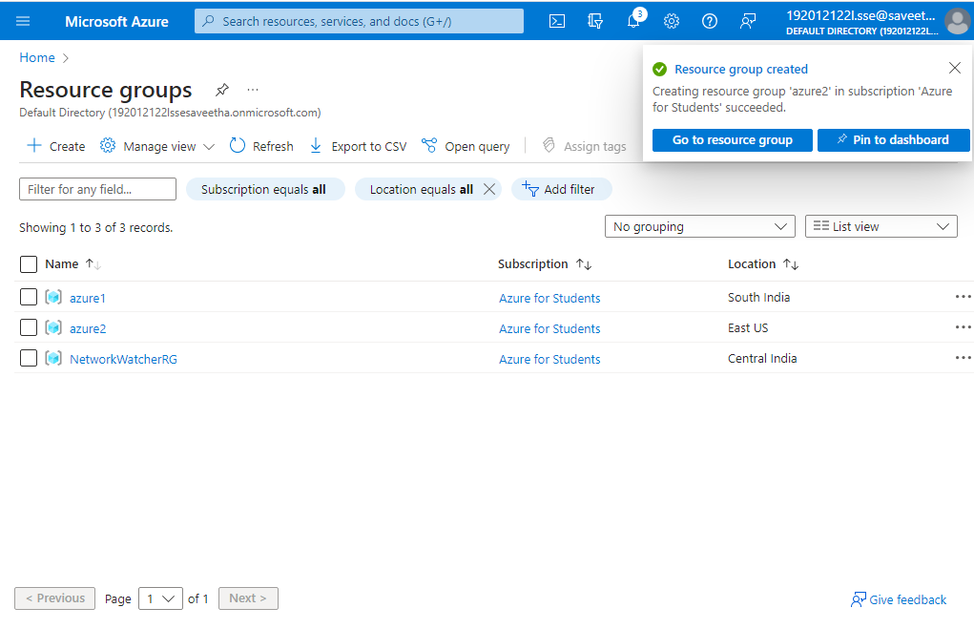

STEP 6:RESOURCE GROUP IS CREATED

